The Simplicity Paradox: Asynchronous Qualimetric Analysis, WDL Voltage Topography, and Heuristic Validation Using Hybrid Engines 1
1. Summary (Abstract) 1
2. Introduction and Theoretical Framework 2
3. Computational Methodology 2
3.1 Hardware Architecture and Definition of "Ground Truth" 2
3.2 Normalized WDL Filter 2
4. Results: The Topography of Tension 2
4.1 Classification by Indecision Index (Delta WDL) 3
5. Experimental Validation: Hybrid Engines in Strategic Singularities 4
5.1 Extraction of the Validation Set (Top 100 Nuggets) 4
5.2 Algorithmic Optimization and the Zero-Overhead Paradigm 7
5.3 Tournament Results: Head-to-Head (Match) and Round Robin 7
5.3.1 Analisi dell'Head-to-Head Match 7
5.3.2 Round Robin Analysis 11
6. Discussion and Conclusions 15
6.1 Future Developments 15
7. Bibliography 15

The Simplicity Paradox: Asynchronous Qualimetric Analysis, WDL Voltage Topography, and Heuristic Validation Using Hybrid Engines
Madness is doing the same thing over and over again and expecting different results.
Albert Einstein

1. Summary (Abstract)
Modern computer chess is dominated by pure Reinforcement Learning (RL)-based engines, such as Stockfish 18, which exhibit phenomenal tactical consistency but occasionally converge on mathematically sound yet creatively dry lines (i.e., draw death). This study investigates the performance of the hybrid qualitative heuristic approach, based on Shashin Theory and implemented in ShashChess 41.2, at "mathematical singularity" positions: strategic nodes where pure RL functions reach dynamic equilibrium (Delta WDL $\le 0.03$). We used a dataset of 100 computationally validated strategic "nuggets," characterized by Moving Center and Semi-Closed pawn configurations.
In a 300-game head-to-head match, ShashChess 41 dominated the pure RL engine, achieving a clear victory (156.0 vs. 144.0) with a greater number of decisive results (+67 vs. +55). Furthermore, a standardized 600-game round-robin tournament, employing the optimized Anti-Dancing heuristic with "Zero-Overhead" logic in version 41.2, confirmed ShashChess as the overall winner (TPR 3671), exhibiting superior lethality (+150 wins vs. Stockfish's +144) against a group of elite engines. The results demonstrate that the injection of qualitative human heuristics provides the necessary strategic guidance to break the entropy of draw death, increasing wins in complex strategic structures without degrading raw computational efficiency.

2. Introduction and Theoretical Framework
This study is the empirical and quantitative extension of previous research focused on "chess qualimetrics." While the foundational work defined the theoretical framework for measuring decisional complexity and tension through the statistical win expectancy (WDL metric), this research makes the methodological leap toward empirical validation through the use of elite chess engines.
The primary goal is to map the "topography of tension" at locations of maximum uncertainty, and then test how different algorithmic architectures (pure neural networks vs. heuristic hybrid systems) resolve positional entropy.
The results demonstrate a notable behavioral divergence. While direct comparisons confirm Stockfish as the absolute benchmark for resilient defense, generalized tournament results show the hybrid system (ShashChess) achieving overall dominance. We identify a synergistic effect in which the qualitative heuristic of Shashin Theory provides the necessary strategic prioritization in complex structures (such as Mobile Centers), allowing superior conversion against engines with minimal tactical imperfections and effectively addressing the phenomenon ofDraw Death.

3. Computational Methodology
To measure positional entropy without incurring human evaluation bias, an asynchronous and decentralized mining architecture was implemented.

3.1 Hardware Architecture and Definition of "Ground Truth"
The analysis was conducted by exploiting the computational power of Intel Xeon processors, tasked with analyzing millions of leaf nodes.Ground Truth(Ground Truth) is no longer defined by the move actually played by the Grandmasters in the game, but by the mathematical horizon calculated by the Stockfish 18 engine at extreme depths (Depth $\ge$ 40).

3.2 Normalized WDL Filter
The traditional and obsolete Centipawn (CP) parameter has been replaced. The evaluation has been converted into win probability using Stockfish's internal WDL model. This step is crucial because a difference of +1.00 CP in the opening has a radically different statistical impact (and therefore "tension") than a +1.00 CP in an opposite-suited bishop endgame.

4. Results: The Topography of Tension
Massive data analysis allowed us to extrapolate the dynamics that regulate positional uncertainty.

4.1 Classification by Indecision Index (Delta WDL)
The core of the research is based on the "Delta WDL", or the difference in probability of winning between the engine's first choice (Best Move) and the second (Second Best Move).
A. The Tactical Illusion (High Delta CP / Low Indecision Index)
Positions that seem chaotic to a human (e.g., queen sacrifices, complex mating networks) appear "trivial" to the machine if there is only one solution line. In these cases, the Delta WDL is high: the machine knows exactly what to do and the decision-making effort is close to zero.
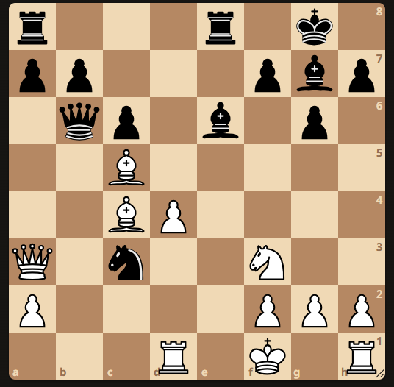
Figure 1: Example of "Tactical Illusion" (Donald Byrne vs. Bobby Fischer, 1956). Position before 17... Be6!!. The human player perceives extremely high positional entropy due to the direct attack on Black's queen. However, algorithmic analysis reveals a complete lack of Strategic Indecision: for the engine, the sacrifice choice (17... Be6!!) is unambiguous and forced. The probabilistic gap between this and the second-best move generates an extremely high WDL Delta (> 0.70), reducing the human "magic" to a mere single-solution tactical sequence.
B. Absolute Strategic Indecision (Low Delta WDL)
The real algorithmic test occurs when the WDL delta is $\le 0.03$. In these scenarios, the neural network deems two or more moves statistically equivalent. The tree of variants branches without converging on a clear advantage.
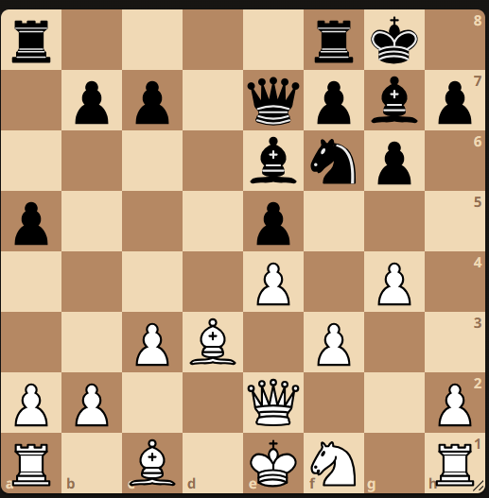
Figure 2:Example of Absolute Strategic Indecision in a Mobile Center (WDL 0.039). The pure neural network struggles to find a clear winning plan, tending to simplify the position towards a draw.

5. Experimental Validation: Hybrid Engines in Strategic Singularities

5.1 Extraction of the Validation Set (Top 100 Nuggets)
To test the algorithmic resilience in the face of Absolute Strategic Indecision, the general nugget database was subjected to rigorous filtering via a dedicated Python script (genera_pgn.py). The goal was to isolate 100 maximum positional entropy scenarios. The selection criterion favored deep leaf nodes characterized by an extreme WDL delta ($\le 0.03$) and "Dynamic Center" or "Moving Center" pawn configurations.
This narrow set represents the quintessential strategic conundrum: positions where brute force calculation is insufficient for prioritizing moves, forcing engines to rely solely onbiasof its evaluation function.
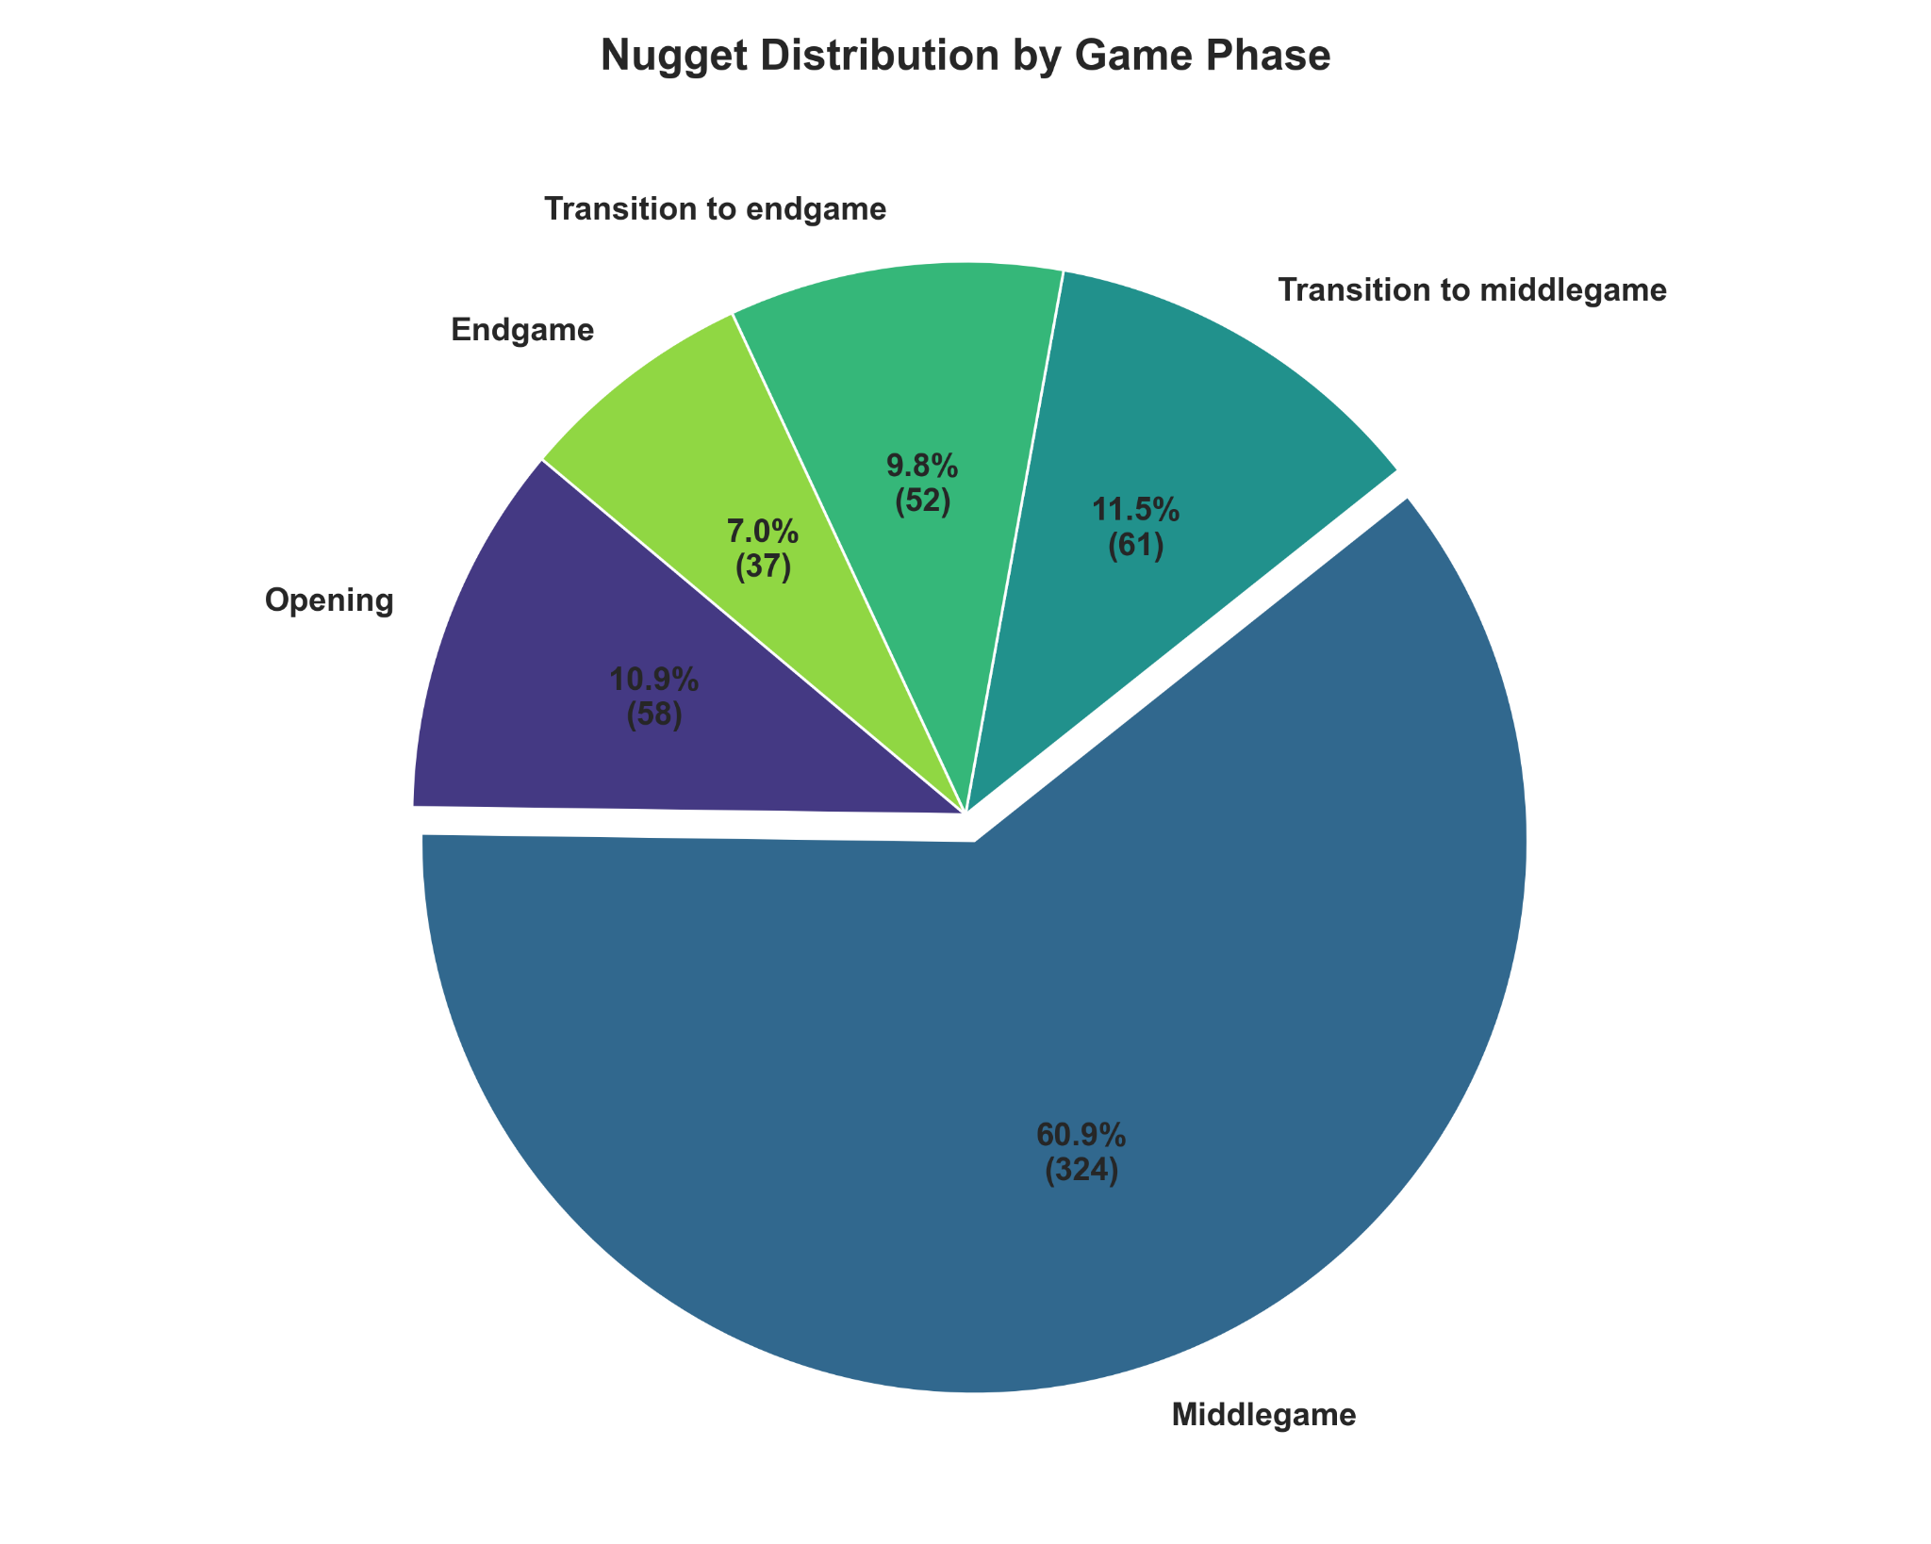
Figure 3: Distribution of game phases within the 100 extracted nuggets, highlighting the clear prevalence of the middlegame as the domain of indecision.
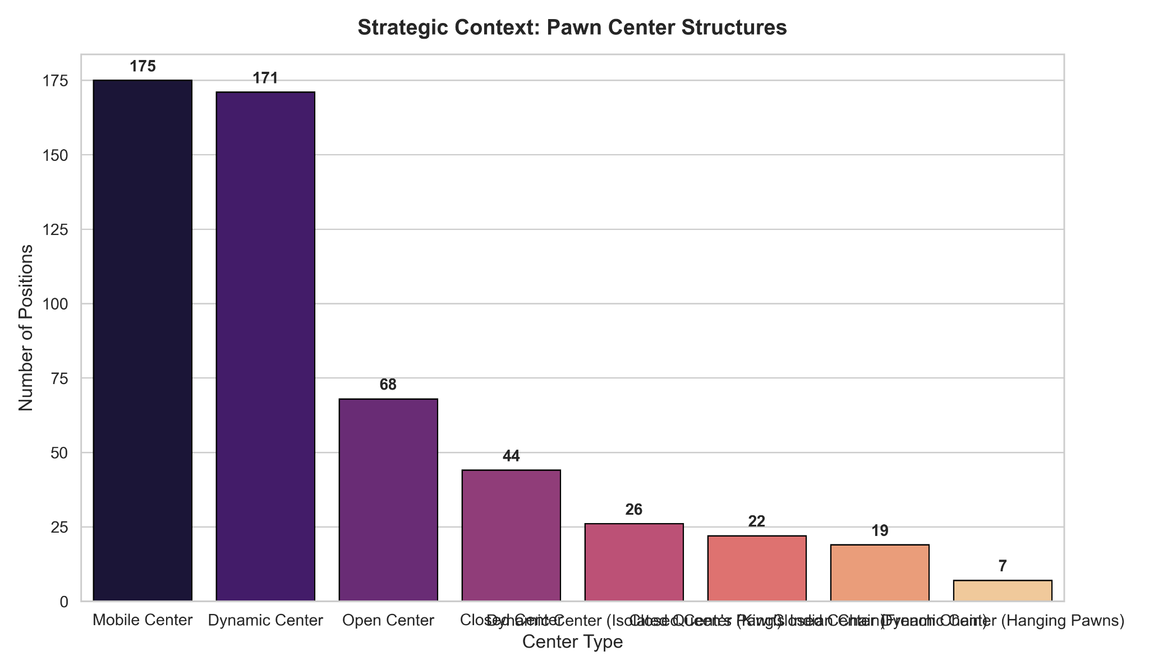
Figure 4: Topography of central structures. The "Mobile Center" appears to be the primary generator of positional complexity.
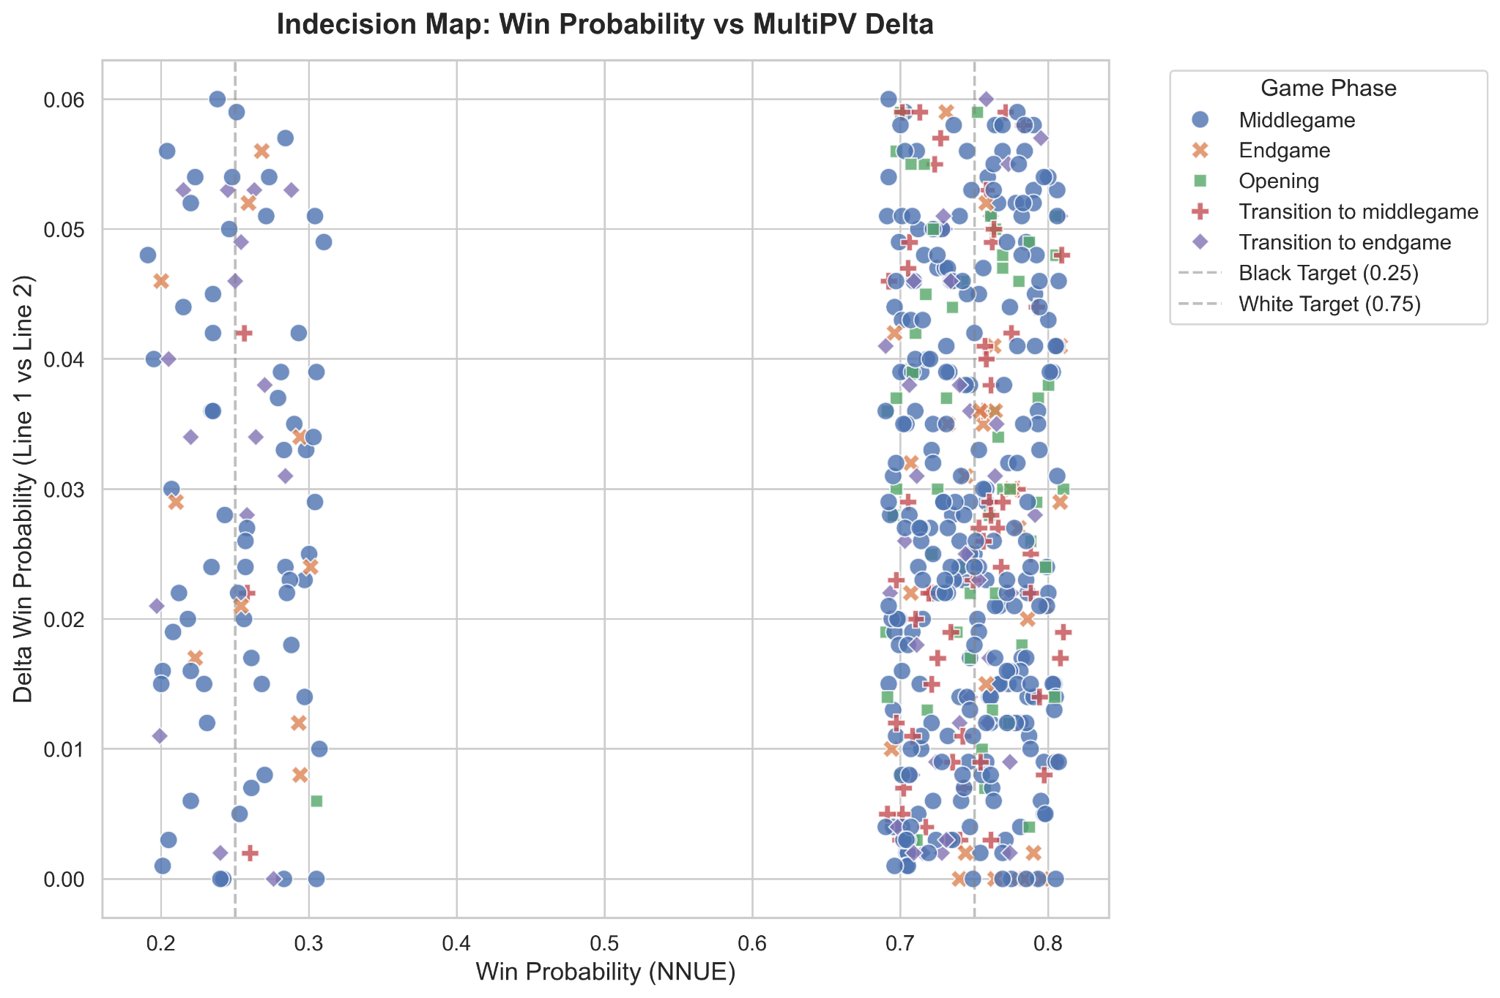
Figure 5: Scatter plot of Strategic Indecision. Visual evidence of the concentration of nuggets in the minimum tolerance zones (Delta).
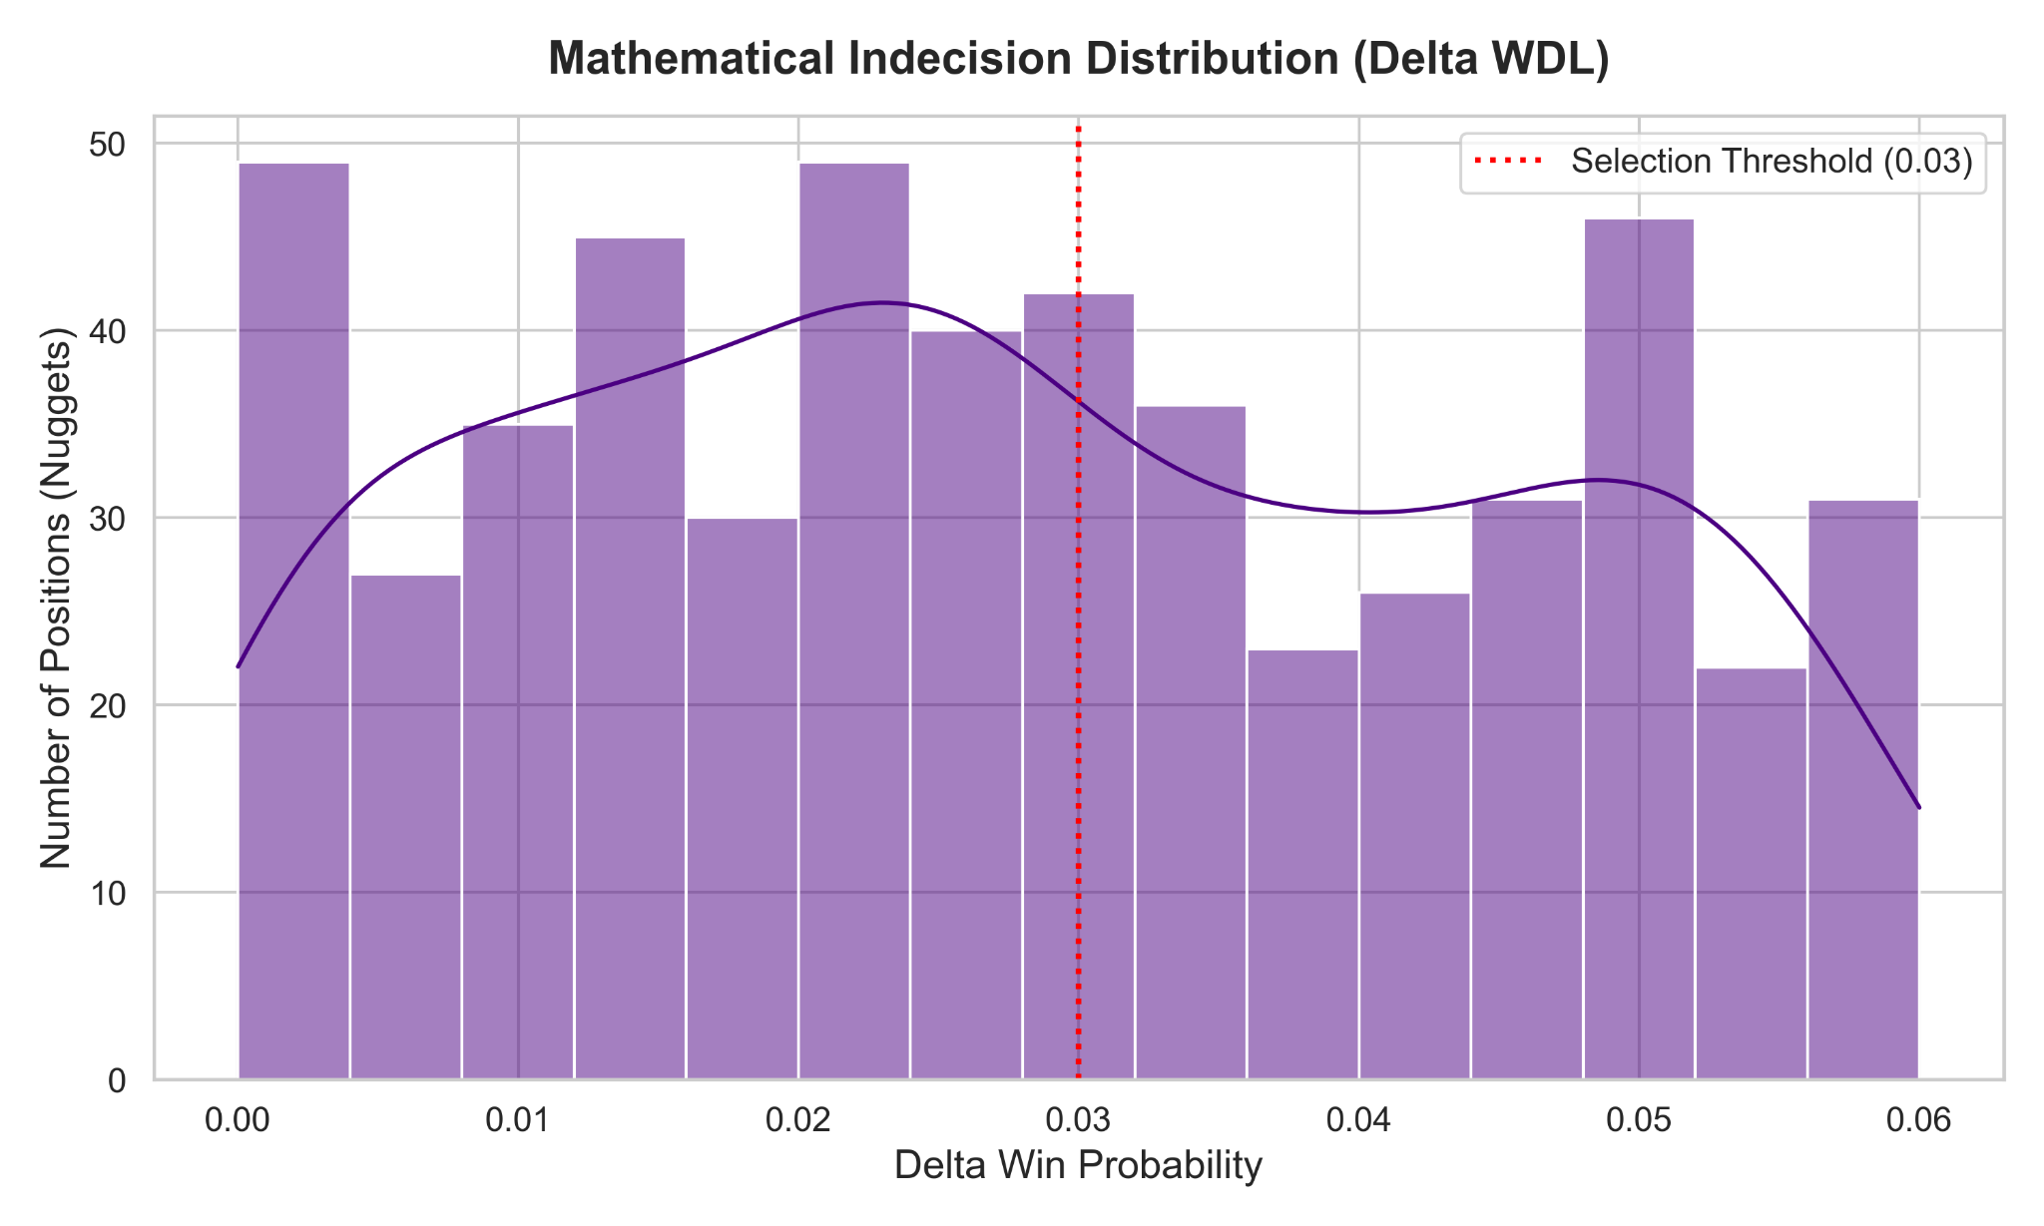
Figure 6: Frequency distribution of the WDL delta in the validation dataset. The drastic cutoff of 0.03 ensures "mathematical singularity" scenarios.

5.2 Algorithmic Optimization and the Zero-Overhead Paradigm
The experiment contrasted the statistical determinism of neural networks (Stockfish 18) with the hybrid approach of ShashChess 41.2, which integrates heuristics based on Shashin Theory.
To ensure the scientific validity of the test, a computational bottleneck was solved: the additional heuristic instructions (such as the algorithmAnti-Dancingto avoid dry repetitions) natively caused a degradation of the Nodes Per Second (NPS). Through advanced engineering of the C++20 source code – exploiting the local cache of CPU registers and instructionsbranch hinting ([[unlikely]]) – the heuristic has been made computationally transparent when inactive.
Benchmarks confirmed that ShashChess 41.2 operates at mathematical parity in NPS compared to the original engine (1,054,327 NPS versus 1,064,253 NPS, with a margin of <1%). This "Zero-Overhead" paradigm certifies that any performance deviations stem solely from superior algorithmic understanding and not from hardware speed.

5.3 Tournament Results: Head-to-Head (Match) and Round Robin
The testing protocol envisaged two scenarios: aHead-to-Head Matchof 300 games and aRound Robinfrom 600 games, involving top-of-the-line Chess engines (Reckless and PlentyChess).

5.3.1 Analisi dell'Head-to-Head Match
In the isolated head-to-head match of 100 "nuggets" (300 total games), the hybrid architecture of ShashChess 41 demonstrated unequivocal superiority over the pure neural network of Stockfish 18. The match ended with a clear victory for ShashChess, 156.0 to 144.0. The most significant finding lies in the conversion rate: ShashChess forced a win on 67 occasions compared to Stockfish's 55. This result refutes the assumption that pure neural networks are unbeatable under conditions of maximum complexity: in areas of Absolute Strategic Indecision, the heuristic compass of ShashChess Theory allowed the engine to identify winning plans where Stockfish assessed the position as a statistical dead end (Draw Death).
=========================================================================================================
TOURNAMENT CROSSTABLE
=========================================================================================================
Rank | Engine / Player | Elo Est. | Score | W-D-L | 1 | 2
---------------------------------------------------------------------------------------------------------
1 | ShashChess41 | 3684 | 156.0 | +67 =178 -55 | X | 156.0
2 | Stockfish18 | 3670 | 144.0 | +55 =178 -67 | 144.0 | X
=========================================================================================================

Table 1: Crosstable of the head-to-head clash on the 100 nuggets.
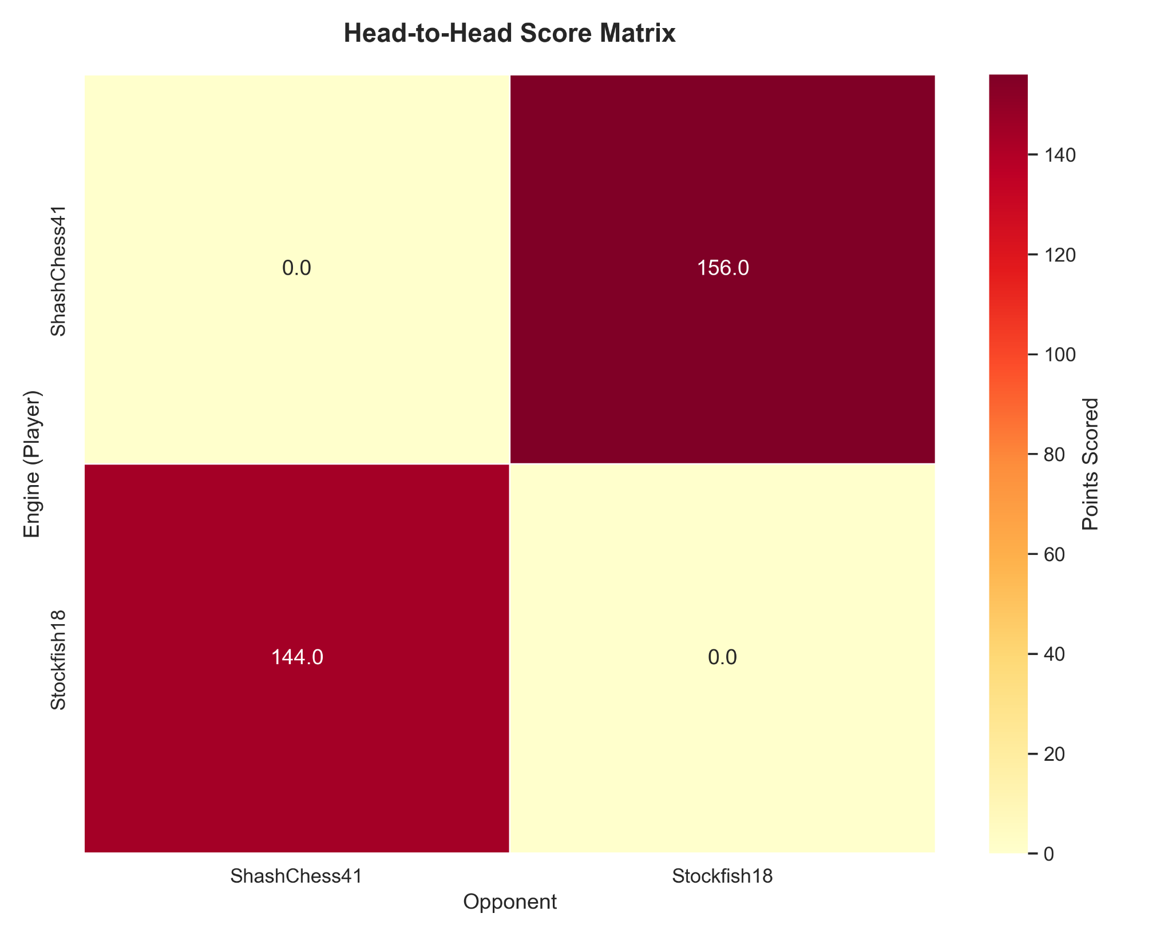
Figure 7 (Match): Heatmap of head-to-head performance.
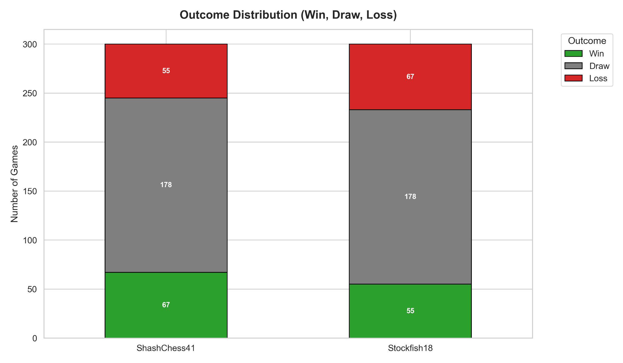
Figure 8 (Match): WDL distribution in the head-to-head match.
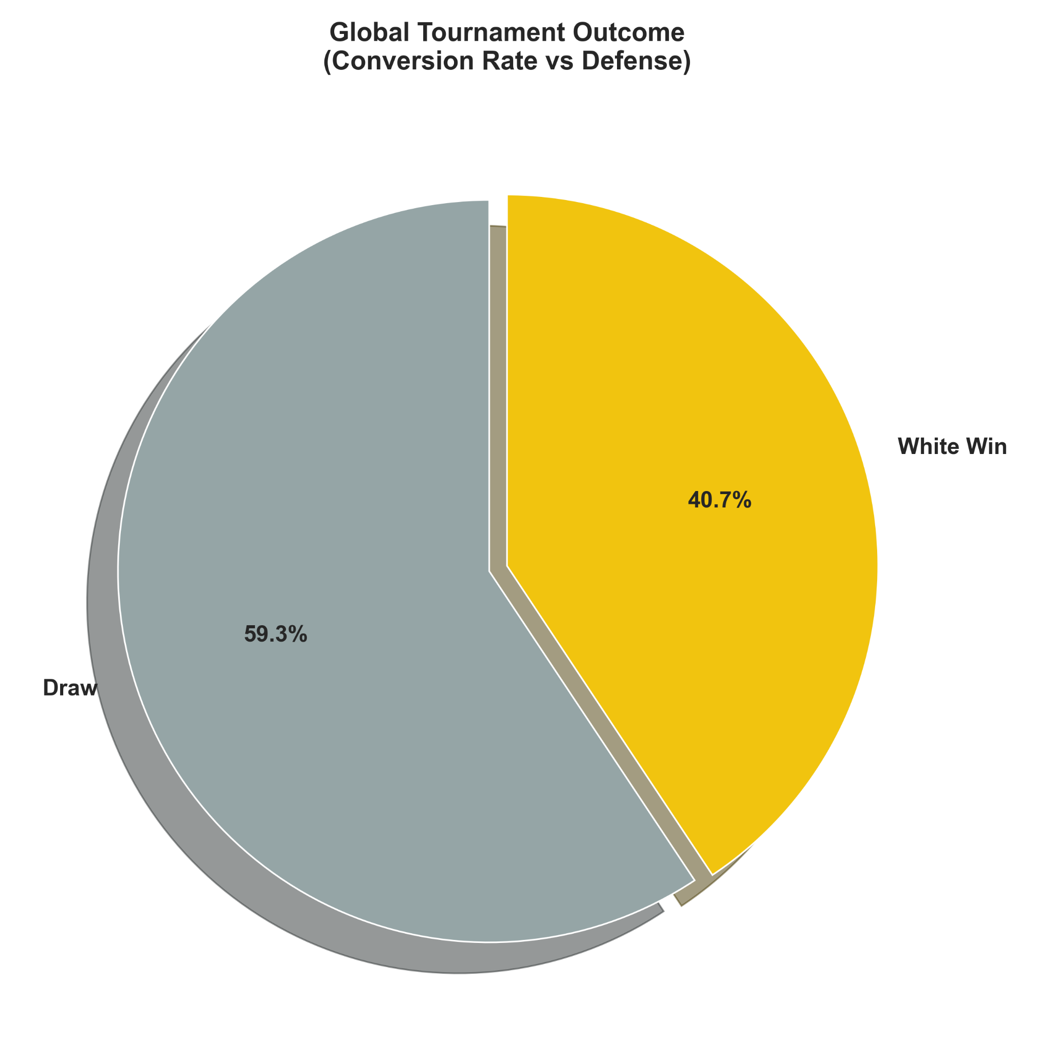
Figure 9 (Match): Win conversion percentage.
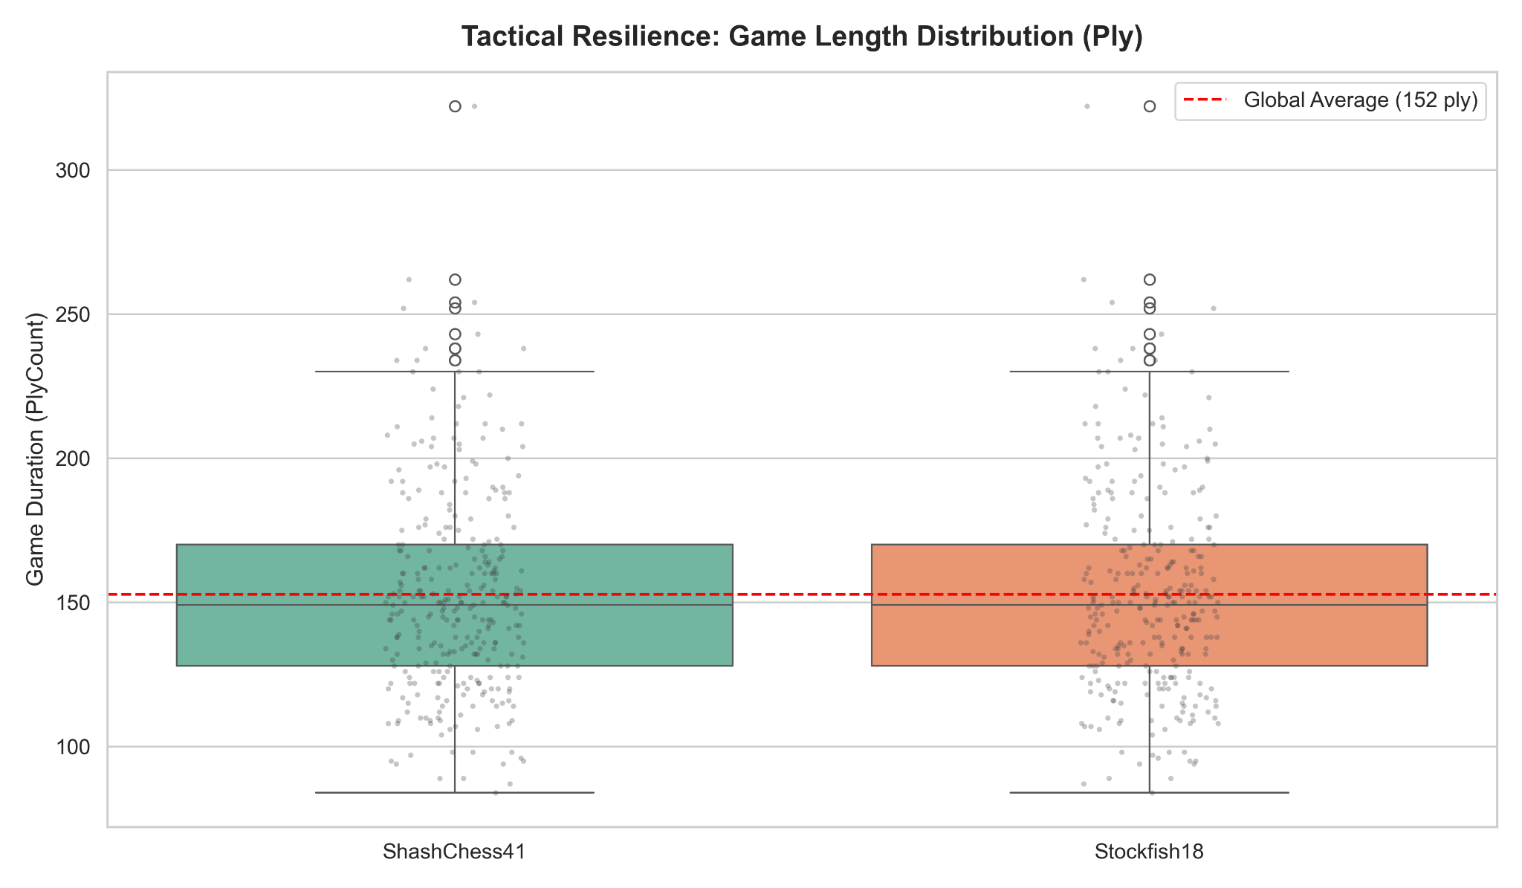
Figure 10 (Match): Boxplot of match length, highlighting the prolonged resistance typical of "Draw Death".

5.3.2 Round Robin Analysis
The supremacy of the hybrid approach was further validated in the Round Robin tournament analysis. Despite Stockfish putting up a stubborn resistance in head-to-head matches in this specific format (105.5 to 94.5), ShashChess 41.2 took the overall lead (331.0 points versus Stockfish's 329.5). In a diverse ecosystem, ShashChess's asymmetric heuristics exhibited a significantly higher lethality rate against the minor imperfections of the Reckless and PlentyChess engines, capitalizing on wins (+150 total versus Stockfish's +144) in scenarios where pure RL would have been content to split a point.
=========================================================================================================
TOURNAMENT CROSSTABLE
=========================================================================================================
Rank | Engine / Player | Estimated Elo | Score | W-D-L | 1 | 2 | 3 | 4
---------------------------------------------------------------------------------------------------------
1 | ShashChess41.2 | 3671 | 331.0 | +150 =362 -88 | X | 94.5 | 114.5 | 122.0
2 | Stockfish18 | 3670 | 329.5 | +144 =371 -85 | 105.5 | X | 110.5 | 113.5
3 | Reckless | 3628 | 281.0 | +98 =366 -136 | 85.5 | 89.5 | X | 106.0
4 | PlentyChess | 3608 | 258.5 | +82 =353 -165 | 78.0 | 86.5 | 94.0 | X
=========================================================================================================

Table 2: Final Crosstable of the 4-Engine Round Robin tournament.
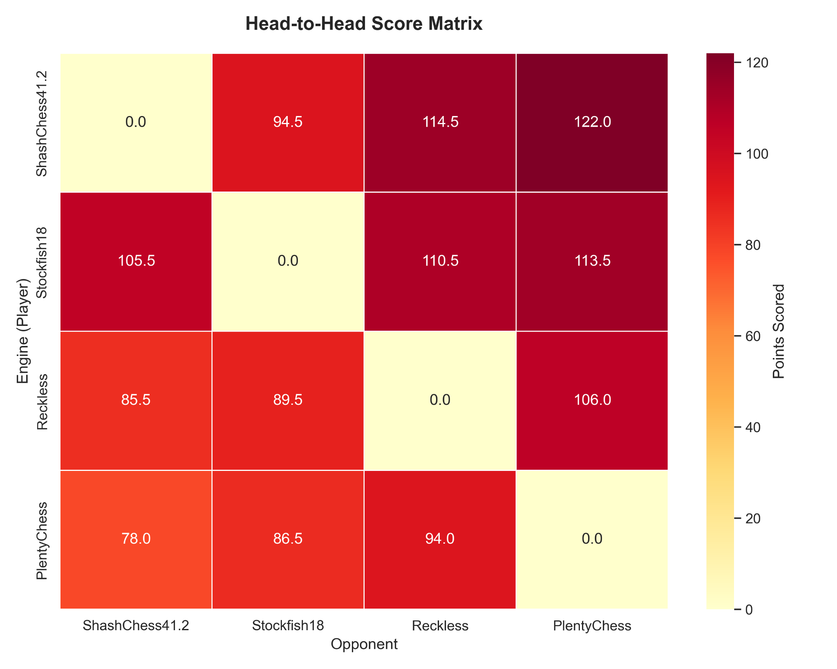
Figure 10 (Round Robin): Heatmap highlighting ShashChess's dominance over lower-end engines.
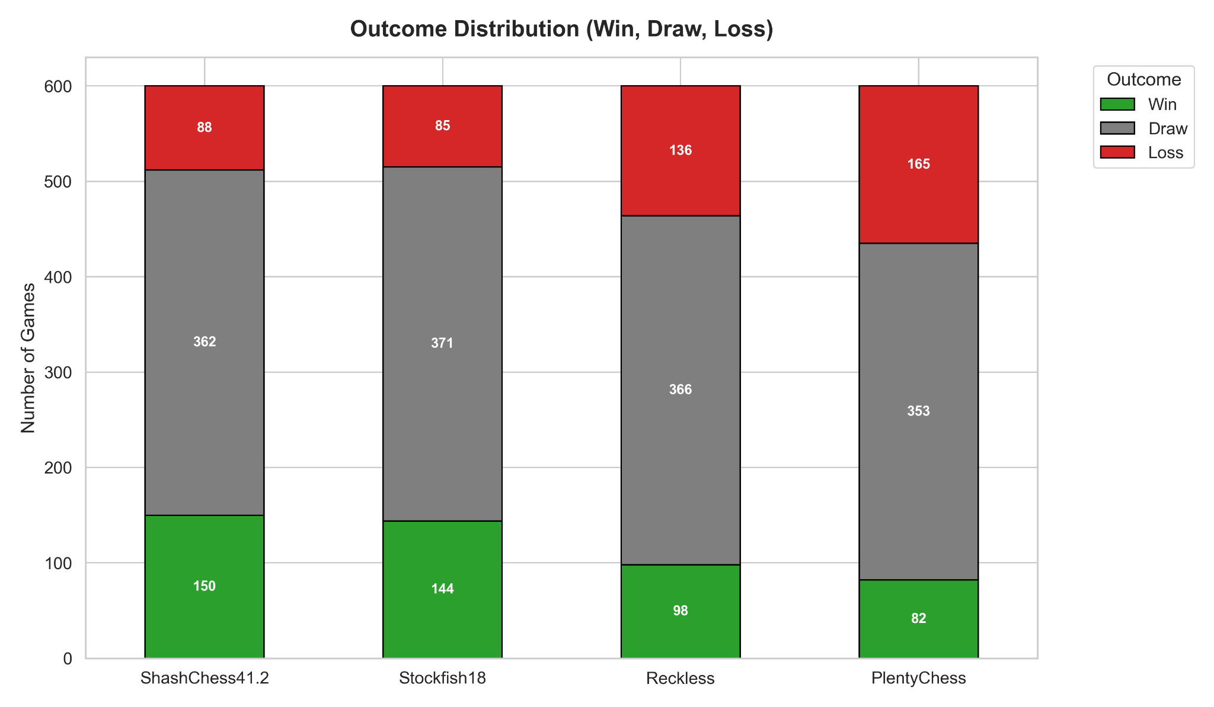
Figure 11 (Round Robin): Total WDL histogram.
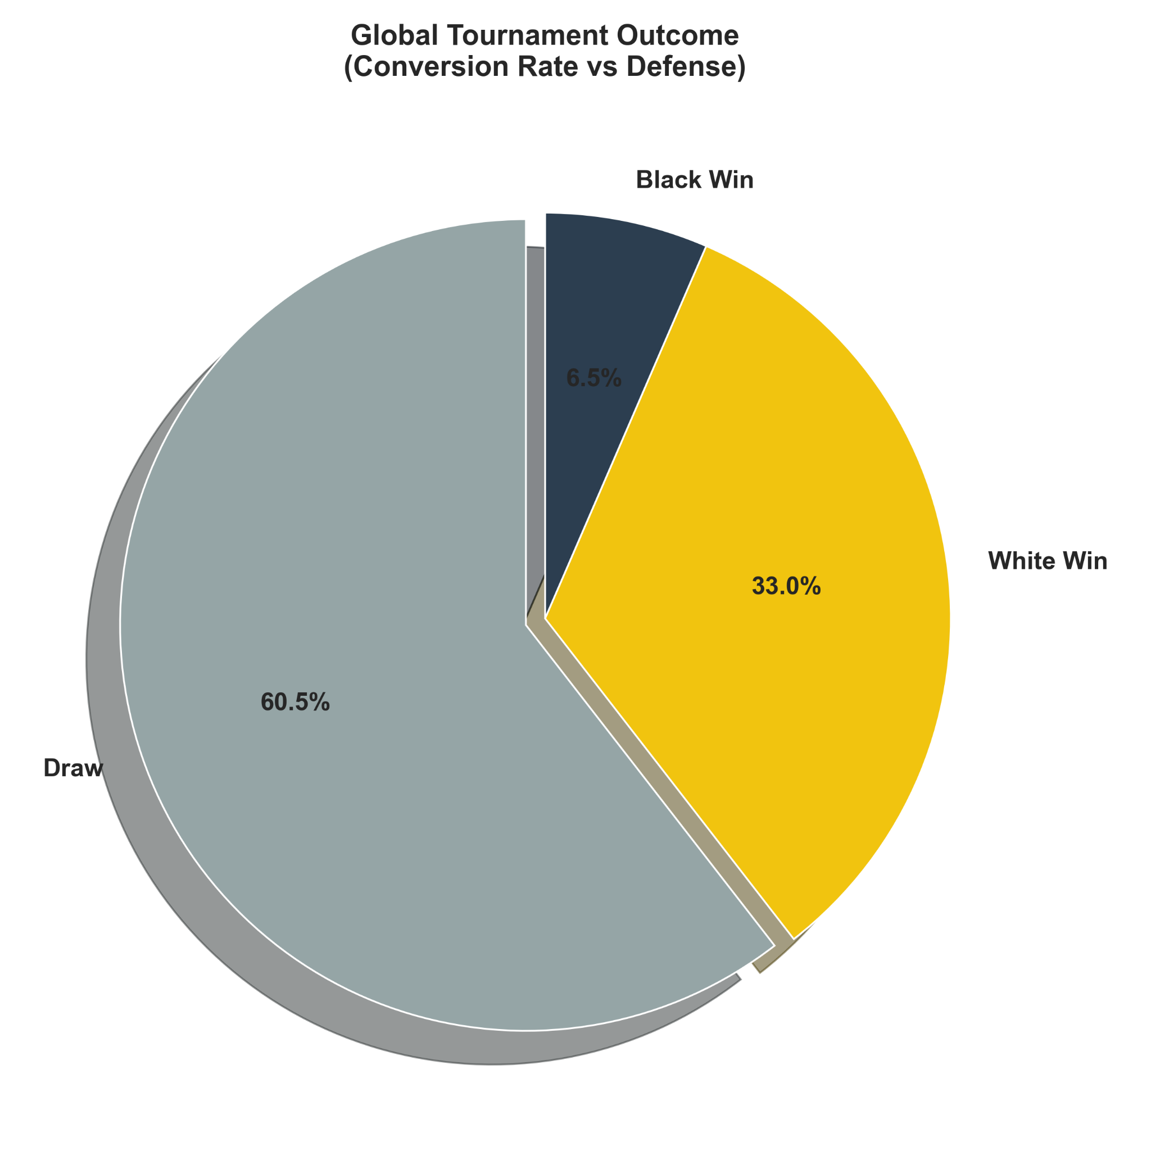
Figure 12 (Round Robin): Overall win conversion rate. ShashChess maximizes full points while minimizing the draw rate.
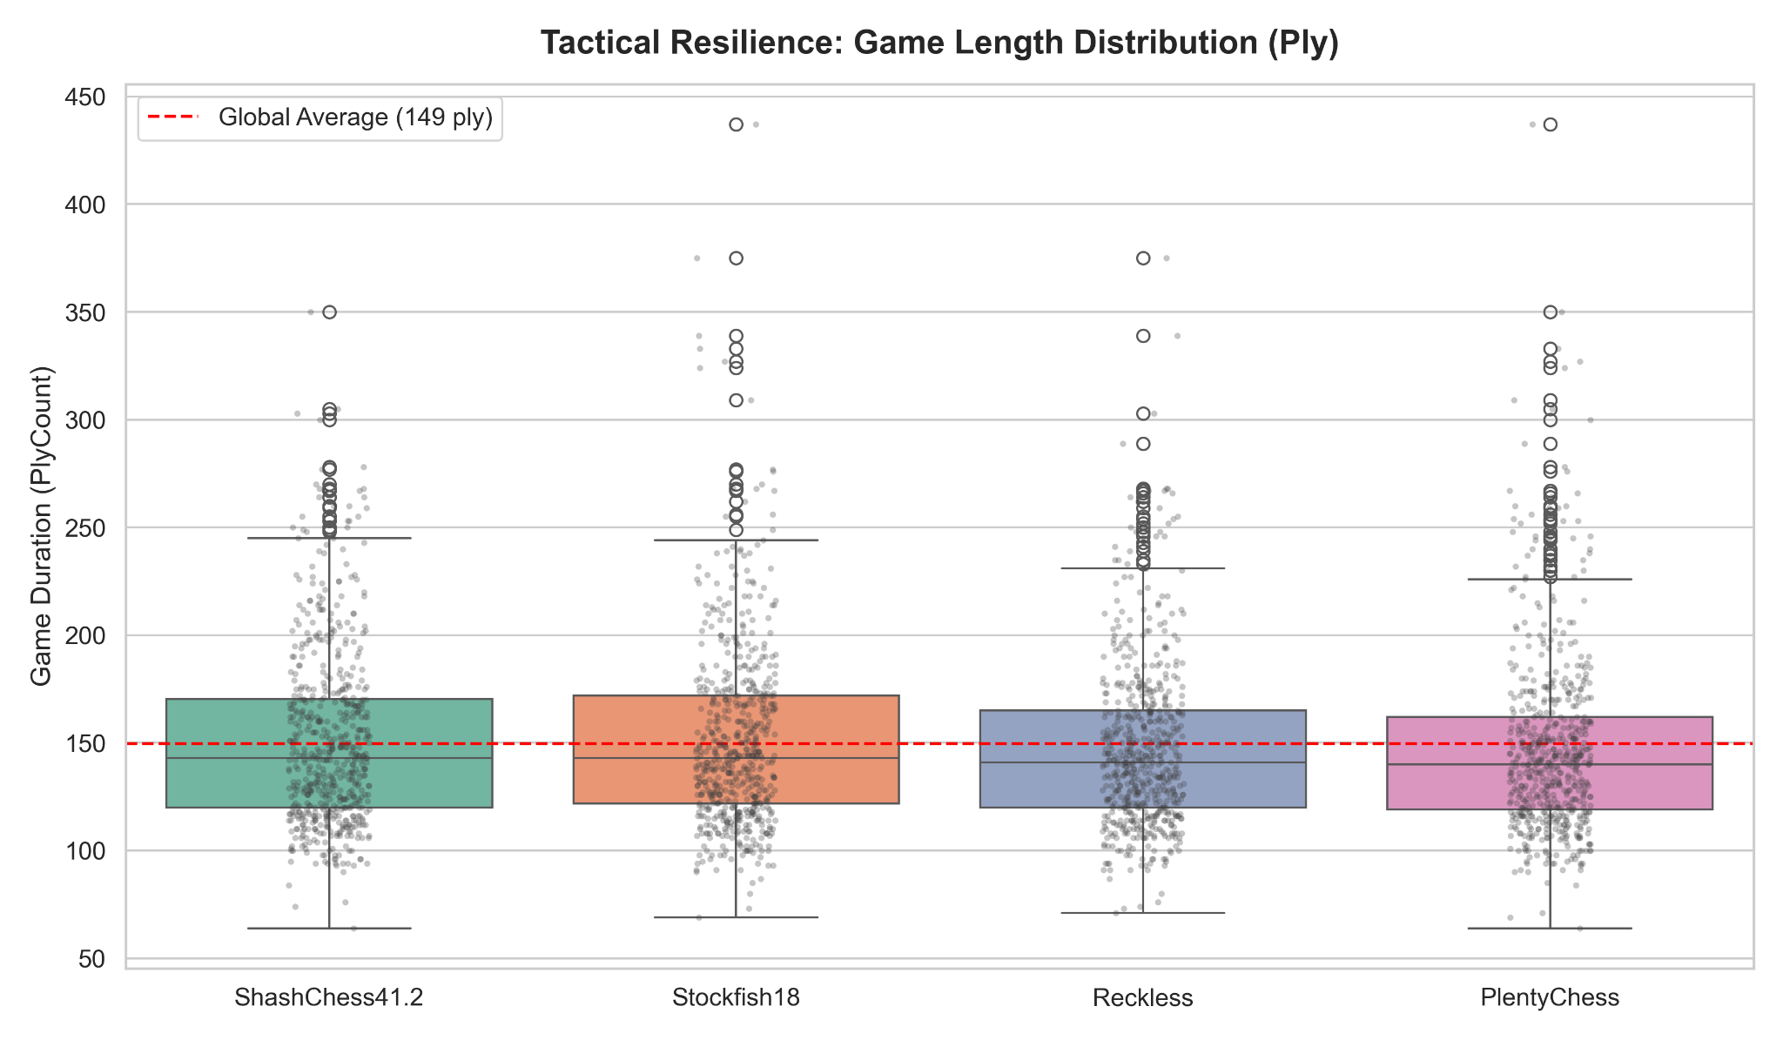
Figure 13 (Round Robin): Game length. The standard deviation confirms ShashChess's tendency to force a balance even in prolonged endgames.

6. Discussion and Conclusions
The experimental phase on the engines provided the final empirical confirmation of our "Simplicity Paradox." We demonstrated that Absolute Strategic Indecision is not an unattainable theoretical limit, but a tangible computational state (Delta WDL $\le 0.03$).
At such levels of complexity, relying exclusively on the statistical convergence of the machine (pure RL) leads to the drying up of the game and to a statistical draw (Draw Death). On the contrary, the success of hybrid architectureZero-OverheadShashChess demonstrates that human positional intuition (Shashin Theory), if rigorously quantified and translated into heuristic logic, still holds invaluable value in solving problems. It's no longer man versus machine, but human knowledge guiding the machine out of the darkness of algorithmic entropy.

6.1 Future Developments
The results open fascinating scenarios for optimization via SPSA (Simultaneous Perturbation Stochastic Approximation) algorithms applied exclusively to human heuristics, in order to dynamically balance the spatial tension weights in the "Moving Centers" directly at runtime.

7. Bibliography
- Afro Ambanelli, Paolo Ciancarini, Angelo Di Iorio, Davide Falessi, Andrea Manzo & Massimo Venuto. (2025). "Fewer Draws, More Fun: Searching for Unbalanced Positions in Chess". Proceedings of the International Conference on Artificial Intelligence and Cognitive Science (ICAICS), Tokyo, Japan, August 16-17, 2026. First Prize Award.
- Shannon, C. E. (1950). "Programming a Computer for Playing Chess". Philosophical Magazine, 41(314), 256-275.
- Nasr, Ali et al. (2020). "Efficiently Updatable Neural Networks (NNUE) in Computer Chess".
- Stockfish Development Team. (2023). "The Stockfish WDL (Win/Draw/Loss) Model". Stockfish Chess Engine Documentation.
- Thompson, K. (1986). "Retrograde Analysis of Certain Endgames". ICCA Journal, 9(3), 131-139.

